Machine Learning Approach to Predict the Invariant Mass of Two Electrons

Deepesh Narayan Raul

Department of Computer Science, S K Somaiya   
Mumbai, India

d.raul@somaiya.edu

***Abstract -* The elementary particles of the universe and its interactions is said to be concise by the Standard Model of high energy physics or particle physics [1]. Particle collider experiments has the capability to produce enormous and information-rich samples of data. Machine learning techniques can be used to develop how these data samples are interpreted, greatly expanding the discovery of potential present and future experiments. In this paper, the data provided by Compact Muon Solenoid built on the Large Hadron Collider at CERN is feature engineered, by introducing new features, analyzing the new features, and using them to increase the performance of the regression model to predict the invariant mass of 2 electrons.**

***Keywords: Machine learning, particle physics, LHS, invariant mass, electrons, regression, feature engineering, correlation.***

1. Introduction

Mid-1970s was when the Standard Model of particle physics was finalized upon the confirmation of quarks, since then, the evidence of top quark in 1995 [2], tau neutrino in 2000 [3-4] and the recent Higgs boson in 2012 [5] have solidified the credence of the Standard Model. This theory describes that every observable objects within this universe is made from basic blocks called elementary particles, ruled by the four forces.

The invariant mass also known as rest mass or intrinsic mass is the fraction of the total mass of an object or system of objects that is independent of the total motion of the system. In particle physics,

$$m_{0}^{2}c^{2}={\left(\frac{E}{c}\right)}^{2}-{\left\|p\right\|}^{2}$$

A collider experiment is used in particle physics research by colliding pair of particles at very high kinetic energy. The Conseil Europ ́een pour la Recherche Nucl ́eaire or as we call it, CERN houses the world’s largest and highest energy particle collider, the Large Hadron Collider (LHS) and the Compact Muon Solenoid (CMS) a particle physics detector. The CMS can generate huge amount of data for particle collisions at 0.9 – 13 TeV. The invariant mass is calculated using a different equation in a particle collider experiments (if particles are highly relativistic, $E≫m,$ or massless),

$$M^{2}=2p_{T1}p_{T2}\left(\cosh\left(η_{1}-η_{2}\right)-\cos\left(ϕ_{1}-ϕ_{2}\right)\right)$$

Where $ϕ_{i}$ is defined as the angular position of particle $i$ in terms of azimuthal angle and pseudo rapidity $η_{i}$. $p_{Ti}$ is the observed transverse momentum.

Using the machine learning we can use robust computing system alongside modern algorithms to observe and analyze insights from enormous amount of data quickly and efficiently. In this paper, we are not only trying to demonstrate the statistical significance of machine learning models in the field of particle physics by predicting the invariant mass of electrons based on the observation from the CMS detectors but also manipulating the features of the dataset by creating new features such that these features show higher relationship with the target variable, Invariant mass and increase the performance of the ML models.

1. Literature Review

Radovic, A, et al. [6], in their research summarized the challenges and opportunities that come with the use of machine learning at the frontiers of particle physics. The paper discusses the challenges of analyzing the big data produced by the LHS experiment and how machine learning helps in real time analysis to combat it. It also touches on the use of deep learning such as CNNs and RNNs as the outputs of many particle-physics detectors can be viewed as images.

Richard M. Flores [7], has done exploratory analysis on the CERN electron dataset [8] and showed the statistical significance in predicting mass in subatomic particle collisions. The model presented by the paper is the CatBoost regression model and only two hyperparameters, “Depth” and “Learning Rate”, were optimized using GridSearch. The model was trained on CERN dataset that was preprocessed and no additional feature engineering was performed.

This paper introduces new features designed from the CERN dataset, which is analyzed to prove its statistical significance compared to the original features and show these features increase the performance of the regression models.

1. Dataset

The dataset used for this research is provided courtesy of the CERN open data portal [8] contains observations of one hundred thousand electrons events in the invariant mass of 2-110 GeV captured by the Compact Muon Solenoid. This data is organized in a CSV spreadsheet file and include the following observations collected by the CMS:

* Run: The run number of the event.
* Event: Number of each event
* E1 and E2: Total energy of the 2 electrons in GeV
* px1, py1, pz1, px2, py2, and pz2: Components of the momentum of the electrons in GeV
* pt1 and pt2: Transverse momentum of the electrons in GeV
* phi1 and phi2: phi angle of the electrons 1 and 2 in rad
* eta1 and eta2: The 2 electrons pseudo-rapidity
* Q1 and Q2: The charge of the electrons
* Invariant Mass M: The invariant mass of two electrons in GeV

As this dataset comes directly from the CERN open portal, it is ensured that the observations are reliable, accurate and has been peer reviewed to be scientifically correct. The data released have been thoroughly analyzed and verified its accuracy through simulation events. Any results provided by this paper can be ensured to be true and accurate.

The dataset is further processed by examining, cleaning, and analyzing the data and its features. As duplicate data are an extreme case of nonrandom sampling, as well as they bias any of the models, leading to overfitting problems. In the case for the CERNs dataset, these duplicates are not real data nor is intentionally oversampled. Duplicate data are removed. After evaluations of the dataset, the target variable M i.e., the Invariant Mass has *NaN* values. The records are removed from the dataset instead of imputing the data as that may lead to false results.

1. Feature Engineering

This section provides the explanation of what manipulation of the features of the data was done and show the analysis of these new features. In statistics, correlation analysis is done to calculate the level of relation between one variable to another. In other words, it measures the linear association between 2 variables.

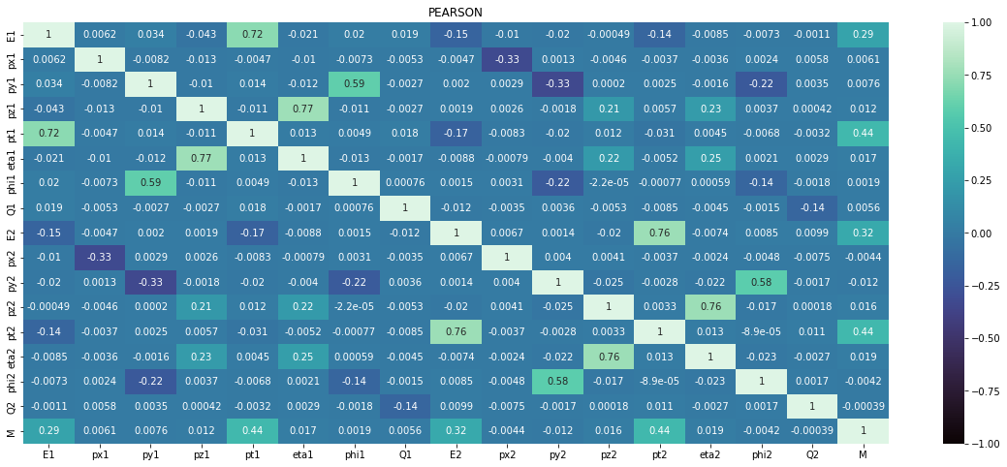

Figure 1 Heatmap for the correlation coefficients of features within the original dataset

Figure 1 is the heatmap for the Pearson’s correlation coefficient [9] values of the dataset. The major focus here is the coefficient value between the target value M and each independent variable. The heatmap reveals that E1, E2, pt1 and pt2 features have high correlation values 0.29, 0.32, 0.44 and 0.44 respectively, with the target M compared to all the other features.

This research presents new features that are created using the original features.

* **E12:** the product of features E1 and E2.
* **pt12:** the product of features pt1 and pt2
* **Similarly, eta12, px12, py12, pz12, phi12,** the products for their respective features.

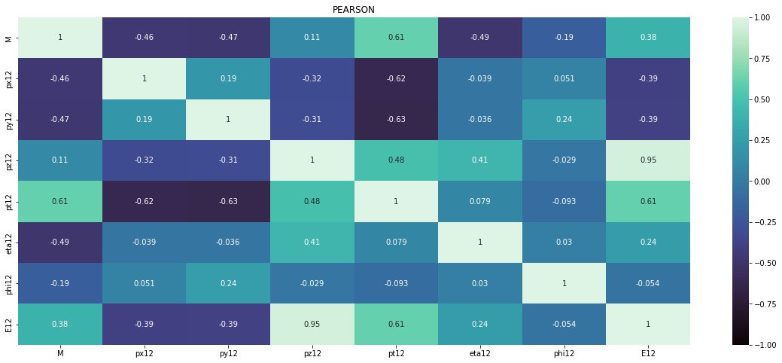

Figure 2 Correlation Heatmap of the new features

The heatmap from Figure 2 shows the correlation between the new features with the dependent variable M. With the min correlation value to be 0.11, we can say that that the new features have good relation to the dependent variable M

TABLE I  
Correlation coefficient value comparison

|  |  |  |  |
| --- | --- | --- | --- |
| **Features** | **Particle 1** | **Particle 2** | **Product** |
| px | 0.0061 | -0.0044 | -0.46 |
| py | 0.0076 | -0.012 | -0.47 |
| pz | 0.012 | 0.016 | 0.11 |
| pt | 0.44 | 0.44 | 0.61 |
| eta | 0.017 | 0.019 | -0.49 |
| phi | 0.0019 | -0.0042 | -0.19 |
| E | 0.29 | 0.32 | 0.38 |

The table I shows the comparison of the correlation coefficient values between the original two features and the new features created using them. We can conclude that the new features are highly correlated to M compared to the parent features.

With the introduction of new features to the dataset, 2 test needs to be done. First, perform the p-value test [10], to prove the significance of the correlation that is evaluated and secondly deal with the problem of multicollinearity.

The p-values test is a measure of significance to validate a hypothesis against the observed results or data. Here, the null hypothesis is that there is no correlation between the features and the target. The threshold for this test is $p<0.05$, wherein the null hypothesis is rejected. The p-values for all the features, including the newly created ones, are calculated using Ordinary Least Square Regression model [11]. Every feature has a p-value less than 0.05 and therefore null hypothesis is rejected, proving the correlations found are significant to use.

As new features are created, the problem of multicollinearity [12] needs to be solved, where 2 or more independent variables are highly correlated with each other. High multicollinearity causes inaccurate results of regression analysis, due to the unstable and biased estimation of the regression coefficients, increases standard error and the variance of the coefficients which in turn also decreases the statistical power. Therefor the highly correlated independent variables are removed.

Multicollinearity is detected by calculating the variance inflation factor (VIF) [11] of each feature in the dataset, it is the measure of how much the standard error of the estimate of the coefficient increased due to multicollinearity.

The threshold, accepted, for the VIF value is less than 10. Above which the feature is removed. For the original data all features (excluding M, the dependent variable) have VIF values below 10.

With the introduction of the new features to the dataset the VIF values are recalculated.

TABLE II  
Features with VIF value > 10

|  |  |
| --- | --- |
| **Features** | **VIF Value** |
| pt2 | 10.668826 |
| pz12 | 93.354042 |
| E12 | 118.840222 |

Table II reveals that 3 features have strong multicollinearity problems. As E12 and pt2 have high correlation with M compared to pz12, seen from figure 2, this feature is dropped and the new recalculated VIF values for all remaining features are within the threshold.

1. Model Selection

Ten regression models are selected and fitted to the original dataset and the new added feature dataset. Following are the regression models used for this research.

Decision Tree Regression is a regression model that uses the concept of decision tree. A model that uses a tree-like model of decisions to predict the target value. Gradient Boosting Regression is a machine learning ensemble technique which predicts target output by combining several weak learners in particular decision tree. LASSO stands for Least Absolute Shrinkage and Selection Operator is a regularization technique, specifically L1 regularization. Ridge regression is a regression model that uses L2 regularization technique. Random Forest Regressor takes same or multiple algorithms, and a model is put together that’s more effective than the original. PLS Regression also known as Partial Least Squares regression is a method that minimizes the predictors to a smaller set of uncorrelated components and performs least squares regression on these components. Elastic net linear regression is a regularized regression that overcomes the limitations of both the lasso and ridge techniques by linearly combining the L1 and L2 penalties of lasso and ridge models.

Decision Tree regression, Gradient Boost, Lasso, Ridge, Elastic net, Random Forest Regressor, and the PLS regression are provided by the scikit-learn library [13].

XGBoost [14] also known as eXtreme Gradient Boosting is a regularizing gradient boosting framework for many languages such as C++, python, scala etc. It is an open-sourced, distributed, scalable gradient-boosted decision tree (GBDT) library developed by The XGBoost Contributors. LightGBM [15], or Light Gradient Boosting Machine is framework of gradient boosting based on decision trees. It is developed by Microsoft and Guolin Ke. CatBoost [16] is also a gradient boosting framework, developed by Yandex. This library is open-source and models can be built in various languages, including C++, python, R and many more. Unlike similar gradient boosting models, CatBoost grows oblivious trees, these trees are grown by enforcing the rule that all nodes at the same level, test the same predictor with the same condition and therefore bitwise operations can be used to calculate the index of the leaf.

Tables III and IV are the evaluation metrics of all the regression models that are fitted on the original dataset and the new dataset respectively. These metrics are calculated by taking the means of the R2 score and RMSE values evaluated across 10 – fold cross-validation. Keep in mind these models are fitted on their default hyperparameters. The four gradient boosting regression models, GBR, LGBM, XGBoost, and CatBoost stand out the most out of all the models.

TABLE III  
Evaluation metrics using original dataset

|  |  |  |
| --- | --- | --- |
| **Model** | **R2 Score** | **RMSE** |
| DecisionTreeRegressor | 0.66747 | 14.55148 |
| CatBoostRegressor | 0.99037 | 2.47511 |
| ElasticNet | 0.39832 | 19.56982 |
| GradientBoostingRegressor | 0.74486 | 12.74279 |
| Lasso | 0.39835 | 19.56938 |
| LGBMRegressor | 0.95843 | 5.14299 |
| PLSRegression | 0.39183 | 19.67583 |
| RandomForestRegressor | 0.90155 | 7.91384 |
| Ridge | 0.39804 | 19.57434 |
| XGBRegressor | 0.96420 | 4.77334 |

TABLE IV  
Evaluation metrics using new dataset

|  |  |  |
| --- | --- | --- |
| **Model** | **R2 Score** | **RMSE** |
| DecisionTreeRegressor | 0.97820 | 3.72371 |
| CatBoostRegressor | 0.99699 | 1.38363 |
| ElasticNet | 0.81897 | 10.73765 |
| GradientBoostingRegressor | 0.98590 | 2.99343 |
| Lasso | 0.82125 | 10.66939 |
| LGBMRegressor | 0.99401 | 1.95138 |
| PLSRegression | 0.79007 | 11.56486 |
| RandomForestRegressor | 0.99092 | 2.40208 |
| Ridge | 0.82179 | 10.65290 |
| XGBRegressor | 0.99333 | 2.05787 |

This paper will be using the CatBoost model for the prediction of invariant mass from this point onwards as it has the best performance out of all the models for both the datasets.

1. Hyperparameter tuning

In the previous section, it is mentioned that the models were evaluated on their default hyperparameters. The software framework Optuna [17] automates the steps involved in hyperparameter optimization. These optimization procedures seek to enhance the performance of a machine learning project while minimizing the time and effort needed to execute it.

Bayesian optimization is a suitable option because it has been demonstrated to outperform other cutting-edge global optimization algorithms. [18] Only continuous hyper-parameters can be optimized using Bayesian methods; categorical ones cannot. TPE short for Tree-structured Parzen estimators uses trees to handle categorical hyper-parameters. [19]. A sampler using TPE algorithm provided by Optuna is used, to find the optimal hyperparameters for the CatBoost Model. This sampler is run over 100 trials and the results, as shown in table V has the best RMSE of 0.92046.

TABLE V  
Best Hyperparameters for CatBoost with RMSE: 0.92046

|  |  |
| --- | --- |
| **Hyperparameters** | **Values** |
| subsample | 0.6571165219995333 |
| od_wait | 46 |
| colsample_bylevel | 0.6900521591366188 |
| random_strength | 2 |
| l2_leaf_reg | 3.3108471723733297 |
| max_depth | 9 |
| n_estimators | 2215 |
| learning_rate | 0.07942397557433238 |

1. Results

The original dataset and the dataset with new features are trained on CatBoost model with the hyperparameters found using Optuna in the previous section. First, we will analyze the impact of the new features on training the model compared to features of the original dataset. This is evaluated using SHAP [20] values, SHapley Additive exPlanations, which is used to make machine learning models more transparent and understandable. For this paper, it is used to show the impact of the features on the CatBoost model.

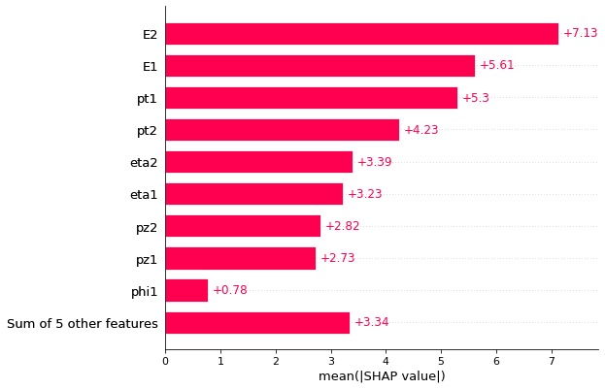

Figure 3 Bar graph of the mean SHAP values calculated for each feature of the original dataset

As seen in figure 3, the features are ordered from the highest to the lowest effect on the prediction. This bar plot considers the absolute SHAP value, as such it does not show the positive or negative impact of the features.

The features E1, E2, pt1, pt2, eta1 and eta2 have high mean SHAP values. This shows these features have higher impact on the prediction then the other features.

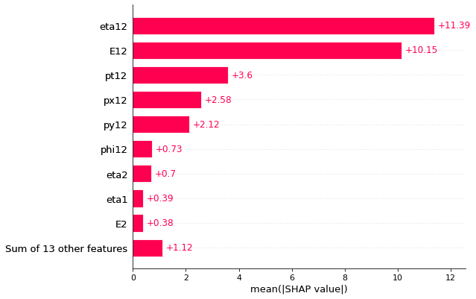

Figure 4 Bar graph of the mean SHAP values calculated for each feature in the dataset that includes the new features.

From the figure 4, it can be inferred that the new features, with higher mean SHAP values. These new features, eta12, E12, pt12, px12, py12, phi12, that are introduced by this paper have a higher impact on the predictions compared to the original features in the dataset.

TABLE VI  
Performance of CatBoost Regression model (10-CV) for Test data of original dataset and new dataset

|  |  |  |
| --- | --- | --- |
| **Evaluation Metrics** | **Original Dataset** | **New Dataset** |
| R2 Score | 0.99405 | 0.99710 |
| RMSE | 1.94644 | 1.35979 |

The original dataset and new dataset are divided into training and testing set with 80/20 split. CatBoost with the optimized hyperparameters is trained with both these training sets. Table VI shows the mean evaluation metrics, across 10-fold cross validation of the test data for both the datasets. It is clear that the new features not only have more influence but also increase the performance of the model.

Figure 5 Joint graph with regression (scatter) plot and histogram of actual values vs predicted value for both new data (left) and original data (right)

There is a very small difference between the R2 score of original dataset and new dataset, as such the joint graph [21] in figure 5 is very similar. As the R2 score of new dataset, 0.99710, is slightly greater than the original dataset, 0.99405, the scatter plot is bit more compressed.

1. Conclusion and Future Scope

This paper introduced new features to the dataset by using feature engineering, demonstrating the strong correlation between these new features and the target invariant mass M, verifying the correlation through p-value test, and removing any multicollinearity that occurred due to the introduction of these features. Using SHAP values, it was proven that these features have a high impact compared to the original features on prediction for the regression models. 10 different regression models were trained and the CatBoost regression model was chosen as it had the best performance. The CatBoost regression model produced a remarkable RMSE value of 1.35979 demonstrating that, despite having only 100,000 records, we were still able to train and test the new dataset successfully and produce results that were meaningful from a model that did not suffer from either underfitting or overfitting.

The findings support our intended research topic and show that the analysis and feature engineering techniques and CatBoost model are fantastic resources for studying and making statistically meaningful predictions in the study of subatomic particle collisions.

For future scope, it is suggested to employ comparable and successful deep learning methods, such as CNN, for future research on this topic and dataset in order to conduct a more extensive analysis and meaningful comparison of the Prediction Models that best meet the objective of this research.

References

1. W. N. Cottingham and D. A. Greenwood, *An Introduction to the Standard Model of Particle Physics,* 2nd Edition, Cambridge, 2007.
2. Abe, F.; et al. (CDF Collaboration). *"Observation of top quark production in $\overline{p}p$ collisions with the Collider-Detector at Fermilab".* Physical Review Letters. 74 (14): 2626–2631, 1995
3. Jackson, Judy; et al. *"Physicists find first direct evidence for tau neutrino at Fermilab"* (Press release). Batavia, IL: Fermilab. 2000
4. Kodama, K.; et al. (DONUT collaboration). *"Observation of tau neutrino interactions"*. Physics Letters B. 504 (3): 218–224, 2001.
5. Ellis, John; Gaillard, Mary K.; Nanopoulos, Dimitri V. *"A Historical Profile of the Higgs Boson"*. ArXiv, 2012.

McCauley, Thomas. *Events with two electrons from 2010.* CERN Open Data Portal. DOI:10.7483/OPENDATA.CMS.PCSW.AHVG, 2014

1. Radovic, Alexander et al. *“Machine learning at the energy and intensity frontiers of particle physics.”* Nature 560 (: 41-48.
2. Richard M. Flores, *“Predicting Invariant Mass of an Electron”* Western Governors University, D214 – Data Analytics Graduate Capston, 2022
3. Freedman, D., Pisani, R. & Purves, R., 2007. *Statistics (international student edition). Pisani, R. Purves,* 4th edn. WW Norton &amp; Company, New York, 2014
4. Karl Pearson F.R.S. X. *On the criterion that a given system of deviations from the probable in the case of a correlated system of variables is such that it can be reasonably supposed to have arisen from random sampling,* The London, Edinburgh, and Dublin Philosophical Magazine and Journal of Science, 50:302, 157-175, DOI: 10.1080/14786440009463897, 1900
5. Schervish MJ . *P Values: What They Are and What They Are Not.* The American Statistician50: 203–206, 1996
6. Seabold, Skipper, and Josef Perktold. *“statsmodels: Econometric and statistical modeling with python.”* Proceedings of the 9th Python in Science Conference, 2010.
7. Farrar, Donald E.; Glauber, Robert R. *"Multicollinearity in Regression Analysis: The Problem Revisited"*. Review of Economics and Statistics. 92–107, 1967
8. Pedregosa et al. “*Scikit-learn: Machine Learning in Python*”, JMLR 12, pp. 2825-2830, 2011.
9. Chen T, Guestrin C. *XGBoost: A Scalable Tree Boosting System.* In: Proceedings of the 22nd ACM SIGKDD International Conference on Knowledge Discovery and Data Mining [Internet]. New York, NY, USA: ACM; p. 785–94, 2016
10. Guolin Ke, et al. *"LightGBM: A Highly Efficient Gradient Boosting Decision Tree"*. Advances in Neural Information Processing Systems 30, pp. 3149-3157, 2017
11. Anna Veronika Dorogush, Vasily Ershov, Andrey Gulin *"CatBoost: gradient boosting with categorical features support"*. arXiv:1810.11363, 2018
12. Takuya Akiba, Shotaro Sano, Toshihiko Yanase, Takeru Ohta, and Masanori Koyama. 2019. *Optuna: A Next-generation Hyperparameter Optimization Framework.* In Proceedings of the 25th ACM SIGKDD International Conference on Knowledge Discovery & Data Mining (KDD '19). Association for Computing Machinery, New York, NY, USA, 2623–2631.
13. Snoek, Jasper, Larochelle, Hugo, and Adams, Ryan P. *Practical Bayesian optimization of machine learning algorithms*. In Advances in Neural Information Processing Systems, pp. 2951–2959, 2012.
14. James Bergstra, Rémi Bardenet, Yoshua Bengio, and Balázs Kégl. *Algorithms for hyper-parameter optimization.* In Proceedings of the 24th International Conference on Neural Information Processing Systems (NIPS'11). Curran Associates Inc., Red Hook, NY, USA, 2546–2554. 2011
15. Lundberg, Scott and Lee, Su-In. *A Unified Approach to Interpreting Model Predictions.* Curran Associates, Inc., 4765-4774, 2017.
16. Waskom, M. L., “*seaborn: statistical data visualization.”* Journal of Open Source Software, 6(60), 3021, https://doi.org/10.21105/joss.03021, 2012